Events

**Ontology Domain**

The purpose of this ontology is to present some of the upcoming events in UK. These events are organized by students for students. The users of ontology would mostly be students who want to socialize and have an active life. The ontology presents a good range of different events and provide users with useful information about the event location, tickets price, tickets availability, etc. It may also suggest popular and sponsored events.

The following competency questions can give an idea of the types of information the ontology would give the answers to.

Competency questions which the ontology should contain enough information to answer include:

* What are the upcoming events in Huddersfield?
* Are there any free-entry events in Leeds?
* Are there any music events which still have tickets available to buy in Manchester?
* What are the charity events taking place in Huddersfield?
* Who are the people going to a particular event?
* What are the events organized by John Smith in Leeds?
* What are the events taking place on 1st of May in the whole country?
* Which events are popular in the country?

This ontology is intended for use by students searching for specific events in their cities and for those who want to promote their events.

The ontology can be explained as follows using classes and object properties:

Events are categorized in different subclasses, they contain the following information, Event Title, Event Ticket Price, Event Date.

An event will be located in a location, which usually have multiple events. Locations could be cities, villages, towns, etc.

An event is organized by organizer. Organizers are the people who organize and promote events. An event can have only one organizer.

Events are visited by visitors. An event can have multiple visitors, while a visitor can go to multiple events.

Tickets for a specific event can either be available or unavailable.

An event can have (but not necessarily) a special class (popular or sponsored).

For this ontology I will use a top-down development process to define the classes in its taxonomy as follows:

* **Event**
* Movies
* Games
* Music
* Party
* Sports
* Volunteering
* Charity
* Food&Drink
* **Location**
* City
* Town
* Village
* **Class**
* Popular
* Sponsored
* **Organizator**
* **Visitor**
* **Ticket**
* Available
* Unavailable

Queries

1. Show all events with location in Huddersfield

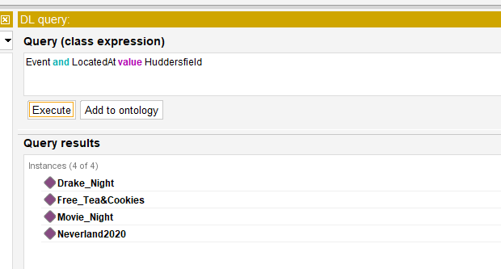

This query shows the only 4 upcoming events in Huddersfield town

1. What are the events with available tickets?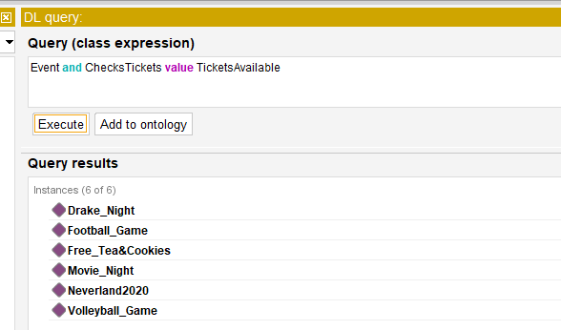

This query shows 6 events with available tickets from all locations

1. Show all sport events

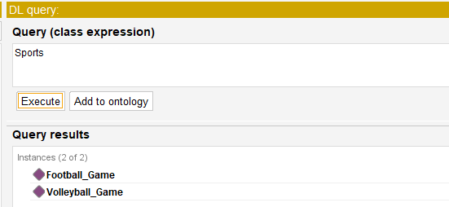

This query shows the only 2 events in sport category

1. What are the events organized by John Smith and located in Leeds?

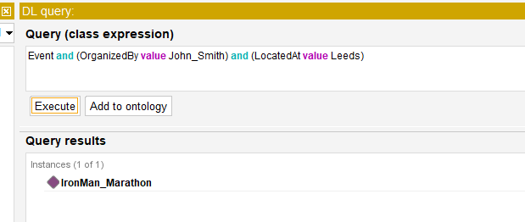

This query shows that IronMan Marathon is organized by John Smith and is located in Leeds

1. What are the party events with free-entry tickets?

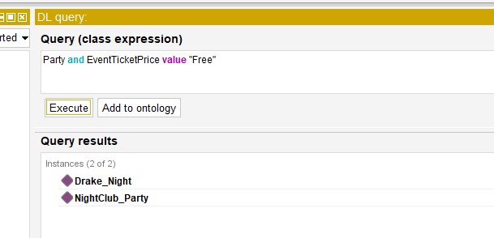

This query shows 2 events which are parties and have free tickets

1. What are the visitors (people) going to Movie Night event?

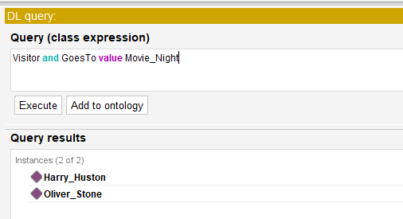

This query shows that 2 people, Harry Huston and Oliver Stone are going to Movie Night event

1. Show the event organizer named Walter White

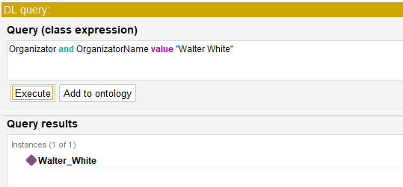

This query shows the profile of organizer named Walter White

1. What are the upcoming events in Huddersfield with free and available tickets?

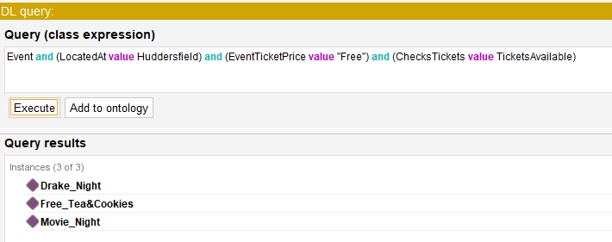

This query shows the only 3 events in Huddersfield town which still have available free tickets

1. What are the events which are going to take place on 1st of May 2020 in Huddersfield?

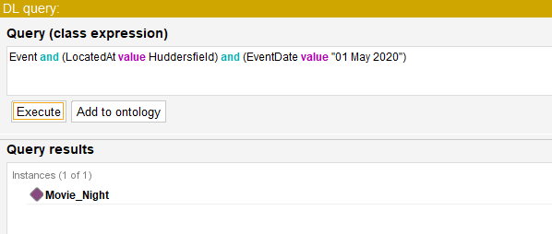

This query shows that Movie Night will be held in Huddersfield on 1st of May 2020

1. Show all locations and Location subclasses

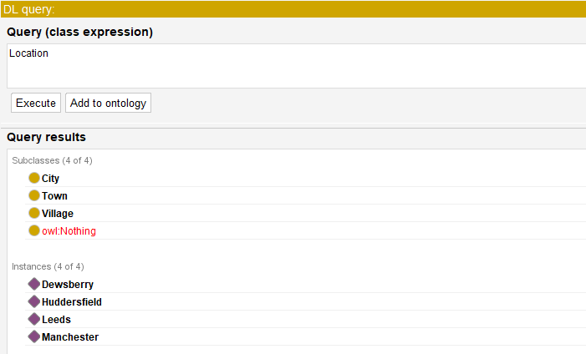

This query shows subclasses of Location and the list of names of the Locations

1. Which event is popular?

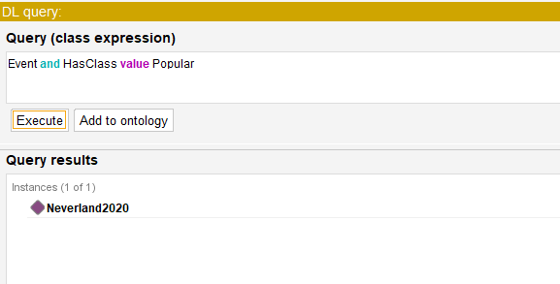

This query shows that Neverland 2020 is classified as popular event.